Photo Identity Card -Request Form

(Write all in Upper Case letters)

First Name: SAMHITHA
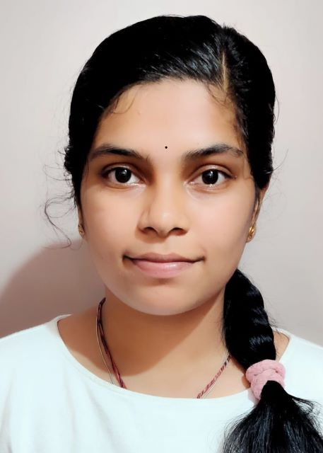

Affix
Passport Size Photo

Last Name: R

Employee ID:

Emergency Contact No: 9738319227

Blood Group: B+

Kindly provide the current address in the below given space in order to courier the ID card.

#62/1, “SHIVA”, 2nd Cross, Srirampuram, Bangalore - 560021________________________________________________________________________________________________________________________________________________________________________________________________________________________________________________________________

